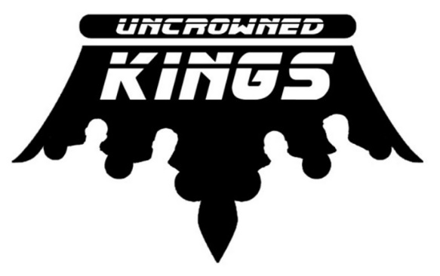

www.theuncrownedkings.com
www.facebook.com/theuncrownedkings
2016 Partial Set List
SONG | ARTIST
Here I Go Again | Whitesnake
Don’t You Forget About Me | Simple Minds
Roadhouse Blues | The Doors
Here Comes My Girl | Tom Petty
Tore Down | Freddie King
Working Man | Merle Haggard
Last Dance with Mary Jane | Tom Petty
Don’t Stop Believing | Journey
Run to You | Bryan Adams
Pride and Joy | Stevie Ray Vaughan
Lights | Journey
One Way Out | Allman Brothers
Just What I Needed | The Cars
That’s Alright Mama | Elvis Presley
Folsom Prison Blues | Johnny Cash
Can’t Get Enough | Bad Company
Your Love | The Outfield
Waitin’ for the Bus/Jesus Left Chicago | ZZ Top
Superstition | Stevie Wonder
Born on the Bayou | CCR
Gimme all your Lovin | ZZ Top
Main Street | Bob Seger
Working for the Weekend | Loverboy
Love Somebody | Keith Urban
New Sensation | INXS
Infatuation | Rod Stewart
Purple Rain | Prince
Separate Ways | Journey
Bye Bye Love | The Cars
Jump | Van Halen
Life in the Fast Lane | The Eagles
Play That Funky Music | Wild Cherry
White Wedding | Billy Idol
Urgent | Foreigner
Rebel Yell | Billy Idol
The Immigrant Song | Led Zeppelin
Whole Lotta Love | Led Zeppelin
Rock and Roll Fantasy | Bad Company
Alright Now | Free
Red Skies at Night | The Fixx
Anyway You Want It | Journey
Suzie Q | CCR
Two Tickets to Paradise | Eddie Money

