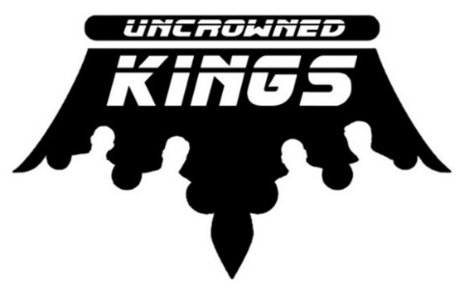

April 20, 2018 Sample Set List
SONG | ARTIST | Lead Vocal
Don’t You Forget About Me | Simple Minds | TJ
Staying alive | Bee Gees | TJ
Here Comes My Girl | Tom Petty | TJ
Just What I Needed | The Cars | Stephen
Tore Down | Freddie King | Stephen
Working Man | Merle Haggard | TJ
Last Dance with Mary Jane | Tom Petty | TJ
All My Love | Buddy Holly | TJ
Hold me now | Thompson Twins | TJ
Pride and Joy | Stevie Ray Vaughan | Stephen
Don’t mess with Jim | Jim Croce | TJ
Sweet Home | Lynard Skynard | TJ
That’s Alright Mama | Elvis Presley | TJ
Folsom Prison Blues | Johnny Cash | TJ
When doves cry | Prince | TJ
La Bamba | Ritchie Valens | TJ
Sex machine | James Brown | TJ and Stephen
Superstition | Stevie Wonder | TJ
Born on the Bayou | CCR | TJ
Lil Red Corvette | Prince | TJ
Rhinestone Cowboy | Glen Campbell | TJ
Jack & Diane | John Cougar Mellencamp | TJ
Working for the Weekend | Loverboy | Stephen
Rock With You | Michael Jackson | TJ
Love Somebody | Keith Urban | TJ
New Sensation | INXS | Stephen
What’s Up | 4 Non Blondes | TJ
Purple Rain | Prince | TJ
Centerfold | J Giles Band | TJ
Bye Bye Love | The Cars | Stephen
Rocket man | Elton John | TJ
Brown Eyed Girl | Van Morrison | Brian
Play That Funky Music | Wild Cherry | TJ
White Wedding | Billy Idol | TJ
Royals | Lorde | TJ
Rebel Yell | Billy Idol | TJ
Raspberry Beret | Prince | TJ
Waterfalls | TLC | TJ
Drift Away | Dobie Gray | TJ
Brick House | The Commodores | TJ
Red Skies at Night | The Fixx | Stephen
Wishing Well | Terence Trent D'Arby | TJ
Keep Your Hands to Yourself | Georgia Satellites | TJ
Two Tickets to Paradise | Eddie Money | Stephen
Sledgehammer | Peter Gabriel | Stephen
Get Down Tonight | KC Sunshine Band | TJ
Ventura Hwy | America | TJ
Oh What a Night | Four Seasons | Stephen
The weight | The Band | Brian
Kiss | Prince | TJ
Feel Like We Do | Peter Frampton | TJ
Big City | Merle Haggard | TJ
Wichita Lineman | Glen Gampbell | TJ
working man | Merle Haggard | TJ
Fireman | Alan Jackson | TJ
Chatahoochie | Alan Jackson | TJ
Amarillo | George Strait | TJ
American Girl | Tom Petty | Stephen
I Want You to Want Me | Cheap Trick | Stephen
Faith | George Michael | TJ
Baba O’Riley | The Who | TJ
Luchenbach TX | Waylon Jennings | TJ
Call me by my name | David Allan Coe | TJ
Fast As You | Dwight Yoakum | TJ
Good Ol Boys | Jerry Reed | TJ
Get A Rhythm | Johnny Cash | TJ
Midnight Special | CCR | TJ
Twist and Shout | Isley Brothers | Stephen
Get Back | The Beatles | Stephen
Gravity | John Mayer | Stephen
My Sharona | The Knack | Stephen
Back in Love | LTD | TJ
Head over Heals | Tears for Fears | TJ and Stephen
Celebration | Kool & The Gang | Stephen
Listen to Her Heart | Tom Petty | Stephen and Brian
Jesse’s Girl | Rick Springfield | TJ
Everybody Wants to Rule the World | Tears for Fears | TJ
Cars | Gary Numan | Stephen

