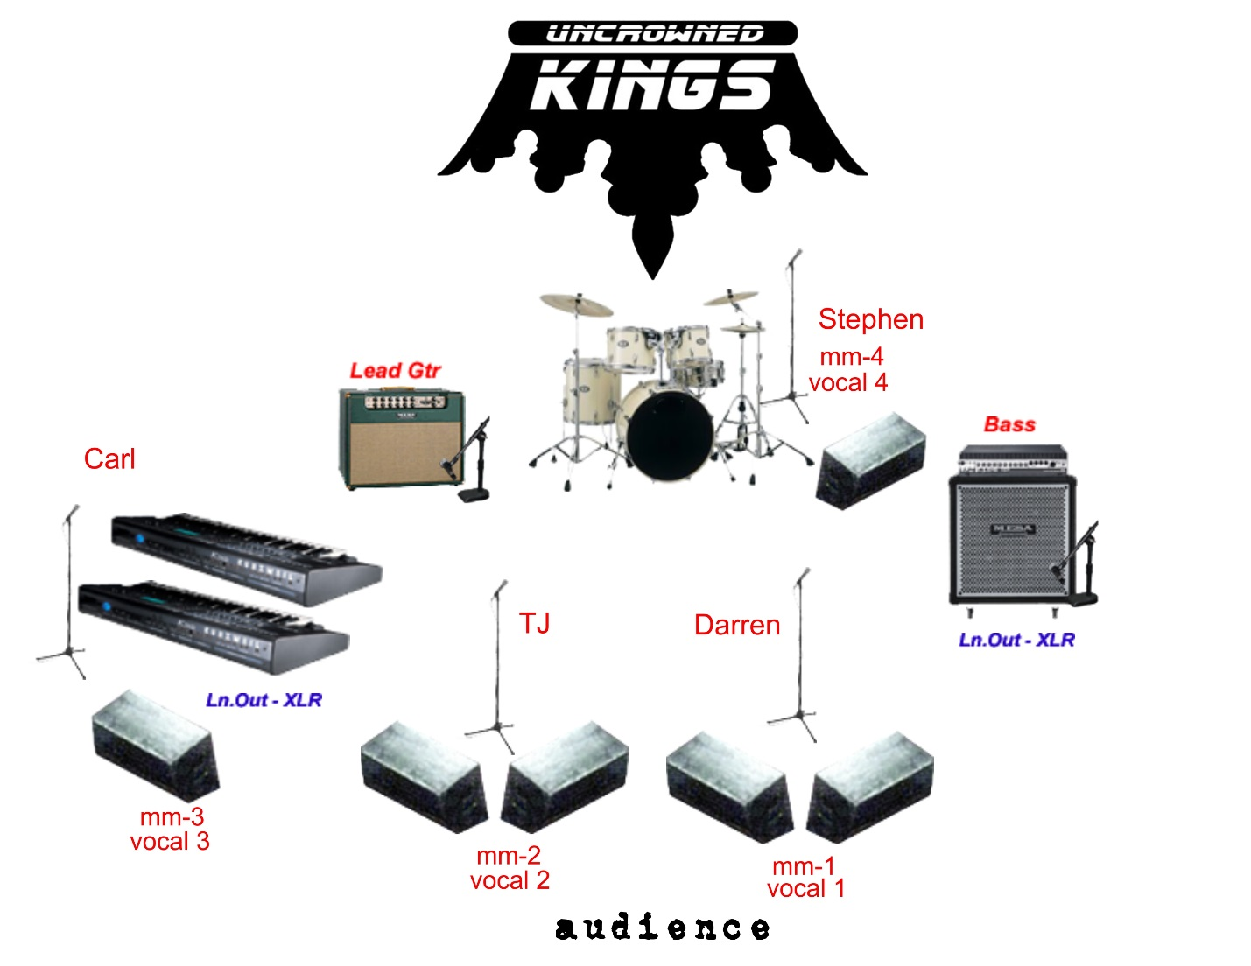

For Detailed information:

Darren Ray: 479-530-8200 [darren.ray@sbcglobal.net](mailto:darren.ray@sbcglobal.net)

Stephen Boudreaux: 479-236-4220 [sboudreaux@arkansas.net](mailto:sboudreaux@arkansas.net)

[www.theuncrownedkings.com](http://www.theuncrownedkings.com)

[www.facebook.com/theuncrownedkings](http://www.facebook.com/theuncrownedkings)

1. Kick
2. Snare
3. R1
4. R2
5. R3(floor)
6. OH Left
7. OH Right
8. Guitar
9. Bass (has DI and/or mic 4X10)
10. Keyboard 1 (DI)
11. Keyboard 2 (DI/organ)
12. Voc 1 (Darren-Lead)
13. Voc 2 (TJ-Guitar)
14. Voc 3 (Carl-Keys)
15. Voc 4 (Stephen-Drum)